Appendix to:
Effects of Fiscal Consolidation
in the Czech Republic
Vladimir Klyuev and Stephen Snudden

Appendix I Calibration Parameters

Table A1 Long-run Growth Rates and Interest Rates (percent per annum)
 | Czech Republic | European Union
Technology growth | 1.5 | 1.5
Population growth | 1 | 1
Long-run Real Interest Rate | 3 | 3
Steady-state inflation rate | 2 | 2
Depreciation Rates
Private Capital Stock | 10 | 10
Public Capital Stock | 4 | 4

Table A2 Elasticities of Substitution
 | Czech Republic | European Union
Nontradables: Capital-Labor | 1 | 1
Tradables: Capital-Labor | 1 | 1
Final Good Import Agents: Different Countries | 1.5 | 1.5
Tradables Import Agents: Different Countries | 1.5 | 1.5
Distributors: Home-Foreign Tradables | 1.5 | 1.5
Inv. Goods Producers: Home-Foreign Tradables | 1.5 | 1.5
Cons. Goods Producers: Home-Foreign Tradables | 1.5 | 1.5
Distributors: Tradables-Nontradables | 0.5 | 0.5
Government: Consumption-Investment Goods | 0.5 | 0.5

Table A3 Utility Functions
 | Czech Republic | European Union
Average Planning Horizon in Years | 10 | 10
Average Remaining Working Life | 20 | 20
Intertemporal Elasticity of Substitution | 0.25 | 0.25
Labor Supply Elasticity | 0.5 | 0.5
Share of Liquidity-constrained Agents | 0.5 | 0.35
Dividend Share of Liq. Constrained Agents | 0.125 | 0.125

Table A4 Steady-state Factor Shares
 |  | Czech Republic |  | European Union
Nontradables Labor Income / GDP |  | 55.6 |  | 63.9
Tradables Labor Income / GDP |  | 49.4 |  | 51.9
Nontradables Output / Manufacturing Output |  | 55 |  | 60
Table A5 Steady-state Expenditure to GDP Ratios
 | Czech Republic |  | European Union
Share in World GDP | 1.1 |  | 98.9
Consumption / GDP | 46.1 |  | 59.0
OLG Consumption / GDP | 30.6 |  | 47.5
LIQ Consumption / GDP | 15.5 |  | 11.5
Private Investment / GDP | 28.0 |  | 18.8
Government Investment / GDP | 4.3 |  | 2.0
Government Consumption / GDP | 17.6 |  | 19.6
Exports / GDP | 77.5 |  | -
Final Goods Exports / GDP | 43.5 |  | -
Intermediate Goods Exports / GDP | 34.0 |  | -
Imports / GDP | 77.5 |  | -
Consumption Goods Imports / GDP | 22.3 |  | -
Investment Goods Imports / GDP | 17.4 |  | -
Intermediate Goods Imports / GDP | 38.8 |  | -

Table A6 Other Steady-State Ratios
 | Czech Republic |  | European Union
Government Debt / GDP |  | 40.4 |  | 80.0

Table A7 Financial Accelerator Sector
 | Czech Republic | European Union
Leverage in Nontradables in % | 100 | 100
Leverage in Tradables in % | 100 | 100
Annual Bankruptcy Rate in Nontradables in % | 8 | 8
Annual Bankruptcy Rate in Tradables in % | 8 | 8
External Finance Premium in Nontradables in % | 2.5 | 2.5
External Finance Premium in Tradables in % | 2.5 | 2.5

Table A8 Monetary and Fiscal Rule Parameters
 | Czech Republic | European Union
Monetary-policy Reaction Function
Lagged Nominal Interest Rate, $δ_{t}$ | 0.32 | 0.34
Inflation, $δ_{π}$ | 1.4 | 1.48
Inflation target, $\overline{π}$ | 2 | 2
Lead on inflation (in quarters) | 4 | 3
Fiscal Rule Parameters
Change in deficit to output gap, 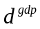 | 0.39 | 0.48

Table A9 Adjustment Costs
 | Czech Republic | European Union
Price Adjustment Costs
Unions | 45 | 60
Distributors | 45 | 60
Non Tradable Sector | 45 | 60
Tradable Sector | 45 | 60
Imported Final Goods | 4.5 | 20
Imports Intermediary Goods | 4.5 | 20
Quantity Adjustment Costs
Consumption | 2 | 2
Investment | 4 | 4
Labor Demand | 1 | 1
Trade Flows of Final Goods | 1 | 1
Trade Flows of Intermediary Goods | 1 | 1

Appendix II Detailed Estimates of Fiscal Multipliers

The following analysis presents the simulations summarized in Figures A1 to A7 and Tables A10 to A16 with labor income taxes satisfying the fiscal rule. Tables A17 to A23 summarize the real GDP values for consolidation with general transfers satisfying the fiscal rule.

Government Consumption Expenditure

Fiscal consolidation with government consumption expenditure has a direct impact on aggregate demand. For a case of a ten year consolidation, credible after one year, see Figure A1, real GDP troughs to -0.4 percent in the first year. The reduction in government demand reduces incomes and results in a fall in real private consumption and investment by 0.2 in the second year. Inflation falls by 4 basis points and the CNB responds with a reduction in the policy rate by 7 basis points over the period of the consolidation. There are substantial leakages into real imports which fall by over one percent. This arises since imports of consumption goods comprise 46.2 percent of the consumption final good. The result is an improvement in the trade balance to GDP ratio of approximately 80 basis points.

After the initial fall in demand, real private consumption and investment begin to be crowded in permanently increasing above baseline by 0.15 and 0.07 percent in the long run. Real GDP returns to baseline after five years, and permanently increases in the long run by 0.05 percent. The long run crowding-in of private demand comes primarily from two channels. First, the reduction in the debt level requires lower tax obligations to service the interest payments on the lover stock of debt. This results in a permanent decrease in labor taxes improving the income of households. Second, the decrease in the debt level is an increase in overall savings which increases the equilibrium level of the world real interest rate in the long run by a small amount. This amount is less than a basis point, since the Czech Republic makes up only a small proportion of global savings.

As the results summarized in Table A10 clearly show, the longer the ZIF binds, the larger real GDP falls in the short run. This arises since the monetary authority cannot reduce interest rates when the consolidation reduces inflation and so there is no offsetting effect from a lower real interest rate on demand.

The results illustrate that, as the credibility of the fiscal authority improves, real GDP will fall by less. As soon as agents perceive the credible fiscal consolidation, they become aware of the lower labor income tax obligations and slightly lower real equilibrium interest rates. In particular, OLG agents increase their consumption as soon as credibility is perceived in an effort to enjoy the additional lifetime income.

In the case when the fiscal authority consolidates for only one year and does not have an impact on future debt levels, the costs to real GDP in the second and third year may be lower, but the long term benefits are not realized. Finally, in the case when the fiscal authority permanently reduces government consumption expenditure, the long term benefits are larger. In particular, real GDP in the long run increases by 0.4 percent, relative to the 0.1 percent in the case of a ten-year consolidation. It takes slightly more time for real GDP to return to baseline in the short run since demand falls throughout the full planning horizon of households, so the observed increase in income takes longer to obtain.

Government Investment Expenditure

Like consumption expenditure, fiscal consolidation with government investment expenditure has a direct impact on aggregate demand. For a case of a ten-year consolidation, credible after one year, see Figure A2, real GDP falls by 0.4 percent in the first year. The decrease in public investment expenditure results in a reduction in the stock of public capital and reduces the productivity in the production of final goods. This results in a gradual fall in real GDP to -1.2 percent after twelve years. The impact on real GDP is very persistent but reverses after the consolidation as the stock of public capital begins to accumulate back to baseline levels.

The reduction in demand for investment goods and lower productivity levels reduces incomes and contributes to a fall of real consumption and investment by -0.5 percent in the second year. Inflation falls persistently by 10 basis points, and after the one year at the ZIF, the CNB responds to cut rates by 20 basis points over the period of the consolidation. There are substantial leakages into real imports. This arises since imports of investment goods comprise 62 percent of the final investment final good. This results in an improvement in the trade balance to GDP ratio of approximately 80 basis points.

The impact of credibility for the case of consolidation with investment expenditure is different than in the case of consolidation via government consumption expenditure, since agents perceive that the reduction in the long-run public capital stocks will reduce their future income. This particularly stands out for the case where the consolidation is credible in year one and the ZIF binds for two years as the perceived reduction in future productivity result in a multiplier of 0.83 in the first year.

The one-year consolidation does not have an impact on future debt levels and has a small impact on the stock of public capital relative to longer consolidations. However, when the fiscal authority permanently reduces government investment expenditure, the long-run costs of the lower public capital stock are obvious with real GDP falling by 2.7 percent in the long run.

General Transfers

Unlike government expenditure, fiscal consolidation with general transfers does not have a direct impact on aggregate demand. As the government decreases transfers to households, OLG agents can respond by borrowing in the short run to finance their expenditure, which they prefer to smooth. The impact on LIQ agents is more pronounced since the reduction in transfers to these agents reduces their consumption immediately by a similar degree to their loss in income. However, since LIQ agents account for only a small share in overall consumption of the economy, the fall is not large.

For the case of a ten-year consolidation, credible after one year, see Figure A3, real GDP falls by 0.07 percent in the first year. This primarily comes from an improvement in the trade balance to GDP ratio which peaks at 0.5 percentage points after five years. The fall in real consumption is pronounced, falling by 1.3 percent by the third year. There is a small reduction in real investment of 0.07 percent by the second year which returns to baseline by year eight. The reduction in demand reduces inflation by 1.5 basis points persistently, and after the one year at the ZIF, the CNB responds to cut rates by approximately 4 basis points over the period of the consolidation. In the long run, real GDP permanently increases by 0.05 percent.

Credibility plays a similar role as consolidation with government consumption where the sooner credibility is perceived the faster the long term benefits of consolidation are observed.
For a temporary consolidation OLG households borrow to smooth their consumption such that there is only a small decrease in real GDP in the first year. For a permanent reduction in general transfers, real GDP in the long run increases by 0.53 percent since there are larger benefits from the lower debt stock.

Targeted Transfers

Fiscal consolidation with targeted transfers has an almost direct impact on aggregate demand by directly reducing the income of liquidity-constrained households. LIQ agents reduce their consumption expenditure in each period identical to their loss of income. The result is a considerably larger fall in consumption than in the case of a consolidation with general transfers. Real private consumption falls by over 2 percent. This comes almost entirely from the consumption of liquidity-constrained households, whose consumption falls by 7 percent.

For the case of a ten-year consolidation, credible after one year, see Figure A4, real GDP falls by 0.25 percent in the first year. There is a reduction in real investment of 0.2 percent by the third year which returns to baseline by year twelve. The reduction in demand reduces inflation by 4 basis points, and the CNB responds by reduction in the policy rate by approximately 6 basis points. There are substantial leakages into imports via imported consumption goods.

Credibility plays a similar role as consolidation with government consumption expenditure since the sooner credibility is perceived the sooner the long term benefits of consolidation are enjoyed.

A permanent reduction in targeted transfers increases real GDP in the long run as the benefits of the consolidation outweigh the reduction in transfer income. In the long run, although real consumption increases by 0.1 percent there is a permanent fall in LIQ agents’ real consumption by 3.6 percent.

Labor Income Taxes

Fiscal consolidation with labor income taxes decreases the income of households and increases distortions in the labor market. These distortions result in a fall in labor supply, reducing an important factor of production. The role of credibility is similar to the case of consolidation with government investment expenditure. When the consolidation becomes credible, households perceive a persistent fall in their incomes as well as a loss in output from higher costs of production. If OLG households perceive the consolidation to be temporary they will try to smooth their income, but as soon as the consolidation becomes credible they perceive the fall in future income which reduces will reduce their demand immediately.

For a case of a ten-year consolidation, credible after one year, see Figure A5, real GDP falls by 0.13 percent in the first year, and falls over 0.5 percent once credibility of achieved. There is a reduction in real investment of 0.5 percent by the fifth year. Real consumption troughs at -1.8 percent and there is a reduction in the real consumption of LIQ households of 4 percent.

A permanent increase in labor income taxes increases real GDP by a small amount in the long run as the benefits of the consolidation outweigh the reduction in labor income and the fall in labor supply.

Consumption Taxes

Fiscal consolidation with consumption taxes affects OLG and LIQ households by their respective shares in total consumption. Although this distorts the consumption decision, it does not affect a factor of production and there is direct distortion on the supply side of the economy. In this way, a higher consumption tax acts in a similar manner to a cut in transfers. The long-run benefits are perceived once the consolidation becomes credible and offsets (partially initially and more than fully later) the impact of an immediate tightening in the household budget constraint.

For a case of a ten-year consolidation, credible after one year, see Figure A6, real GDP troughs at-0.18 by the second year. Real consumption falls by almost 2 percent and does not return to baseline levels until 40 years. In the long run, real GDP permanently increases by 0.05 percent. Again the long-run impact arises from the reduction in lower tax obligations to service the debt, and lower equilibrium real interest rates.

Capital Income Taxes

Fiscal consolidation with capital income taxes affects the income of OLG households and increases distortions in the capital market. These distortions result in a fall in the stock of capital causing a reduction in an important factor of production. The role that credibility plays is similar to that of consolidation with labor income taxes. When, the consolidation becomes credible households perceive a persistent fall in their incomes as well as a loss in output from higher costs of production. For OLG households, if they perceive the consolidation to be temporary they will to smooth their income, but as soon as the consolidation becomes credible they perceive the fall in income and production.

For a case of a ten-year consolidation, credible after one year, see Figure A7, real GDP falls by 0.7 percent after several years. There is a reduction in real investment of almost 3 percent which returns to baseline by year fifteen, and real consumption troughs at -1.1 percent after the third year.

A permanent increase in capital income taxes results in a decrease in real GDP in the long run of 0.42 percent relative to baseline. Real GDP in the long run falls because the distortionary impact of higher capital taxes is greater than the gains from the consolidation.

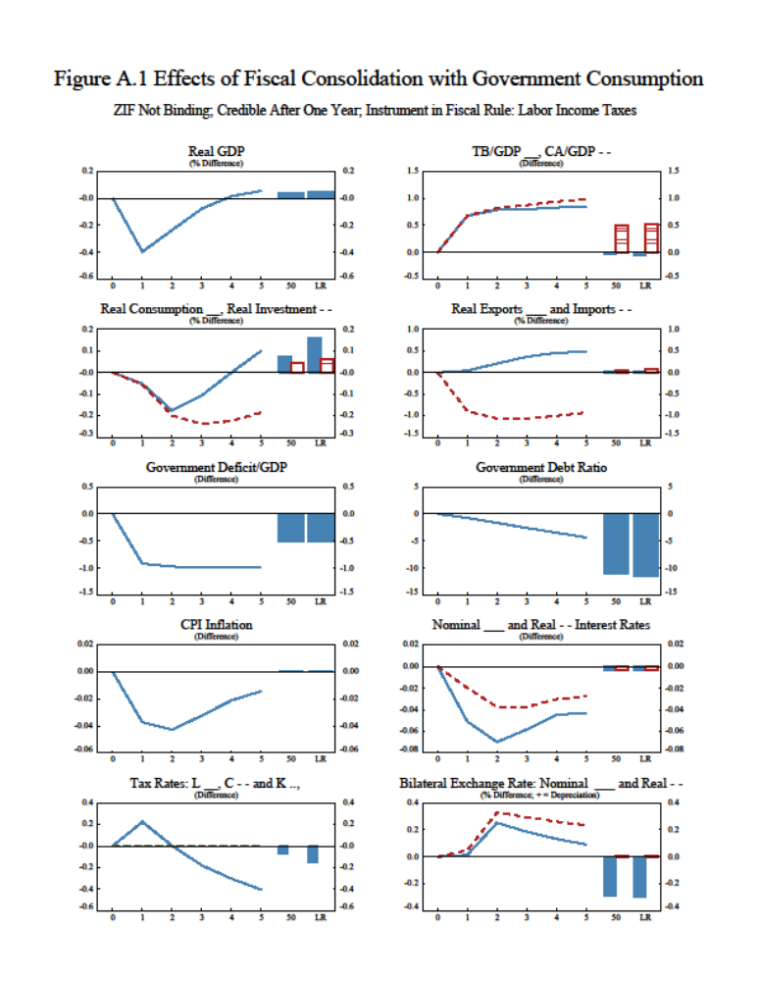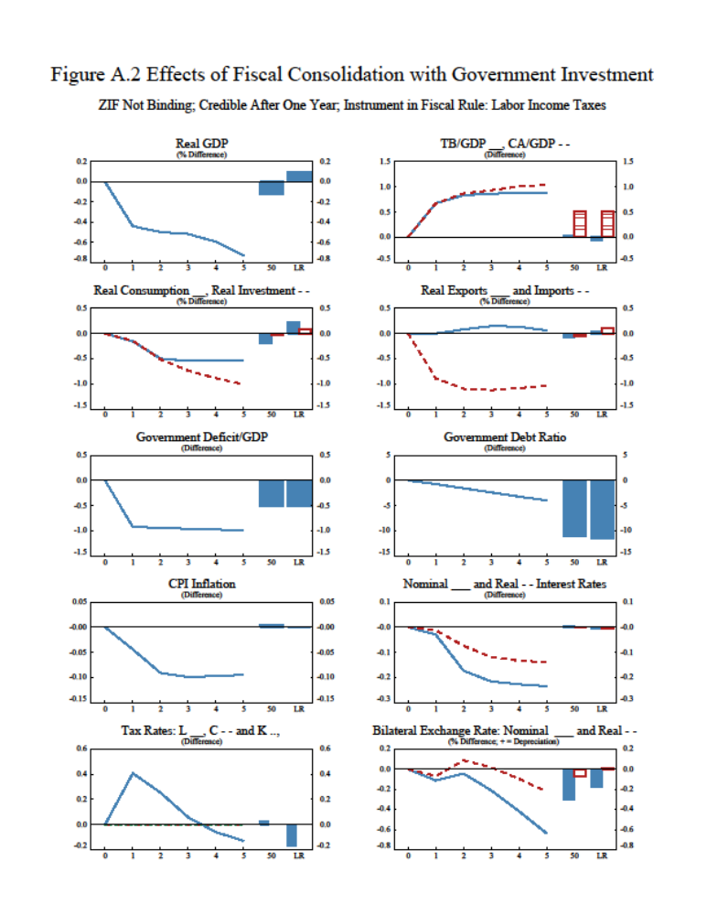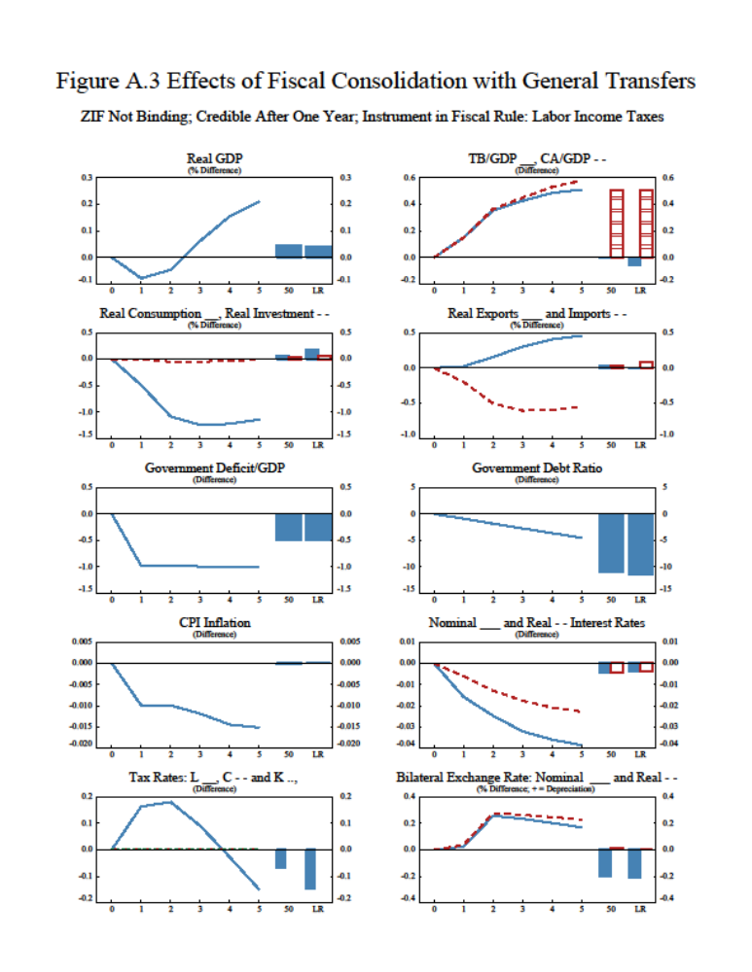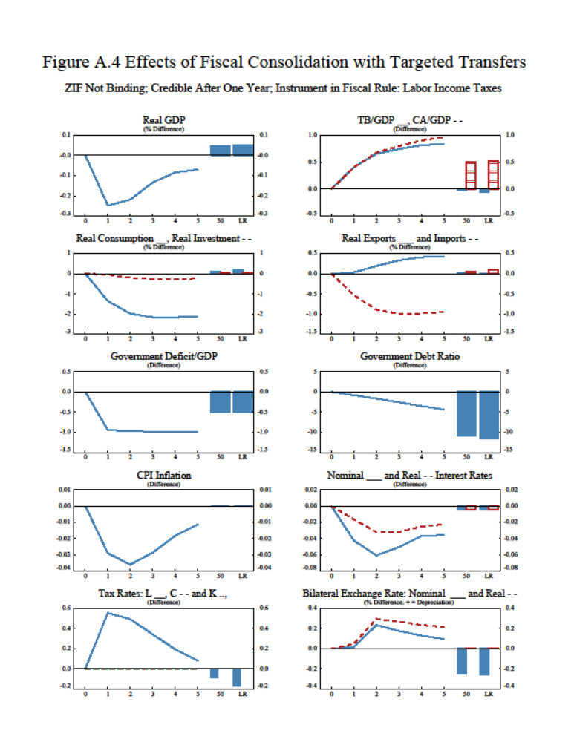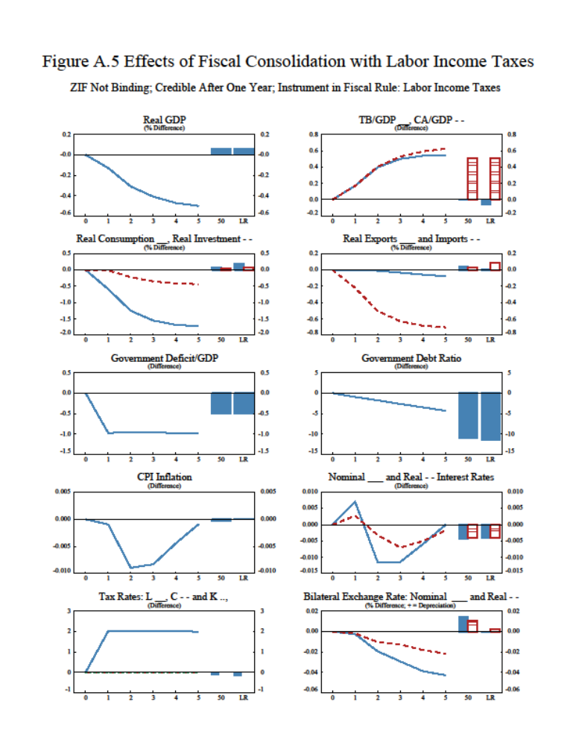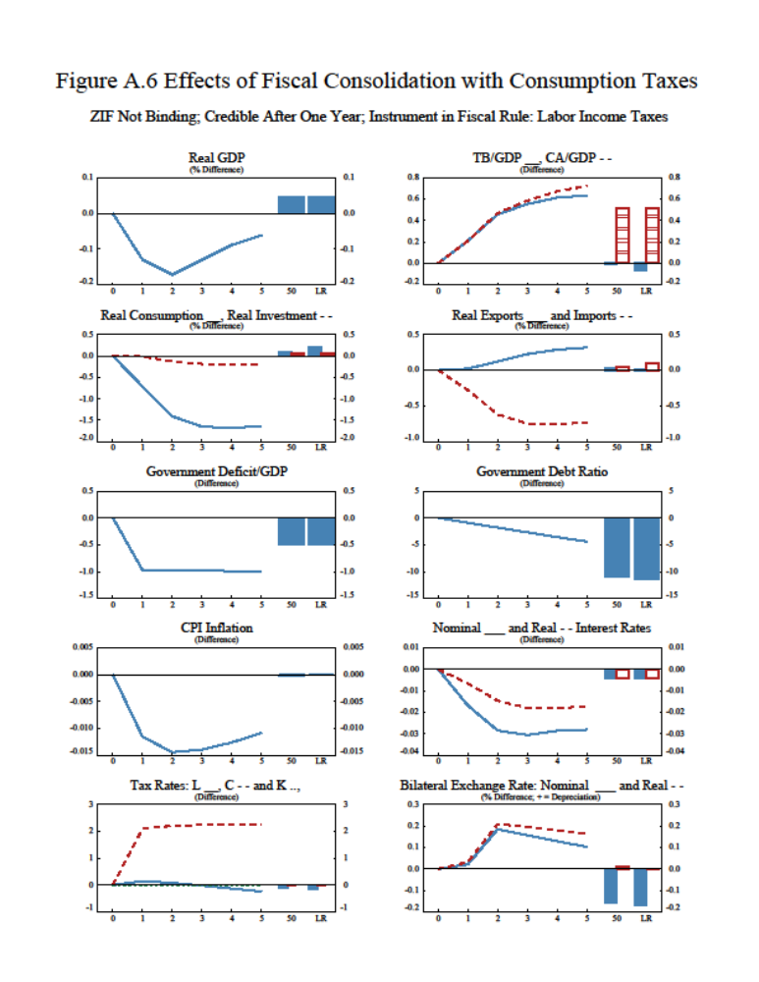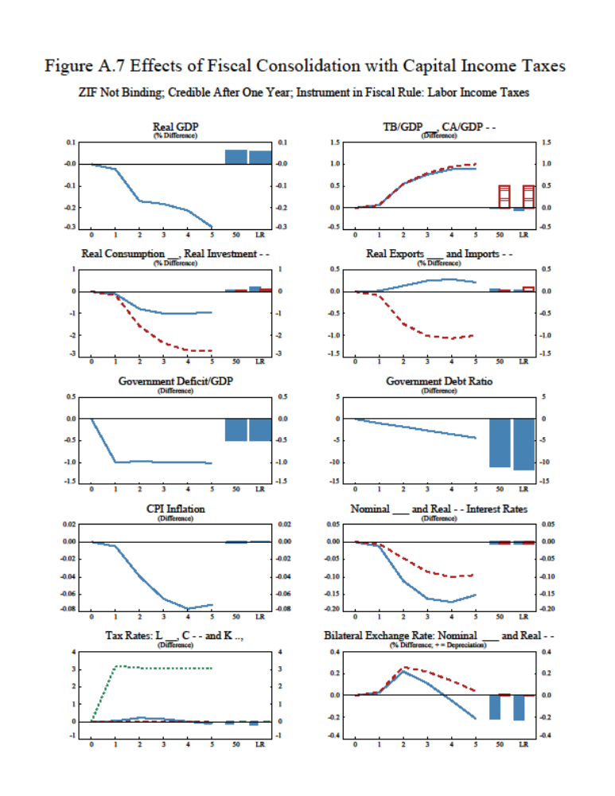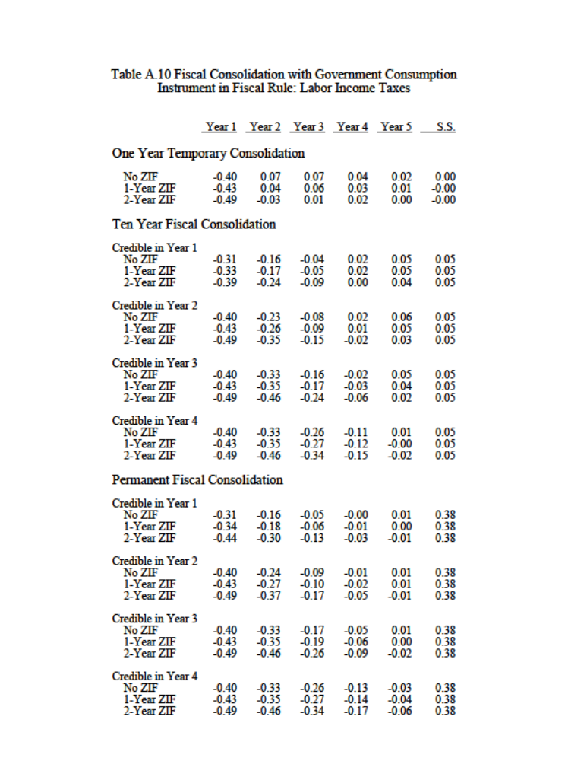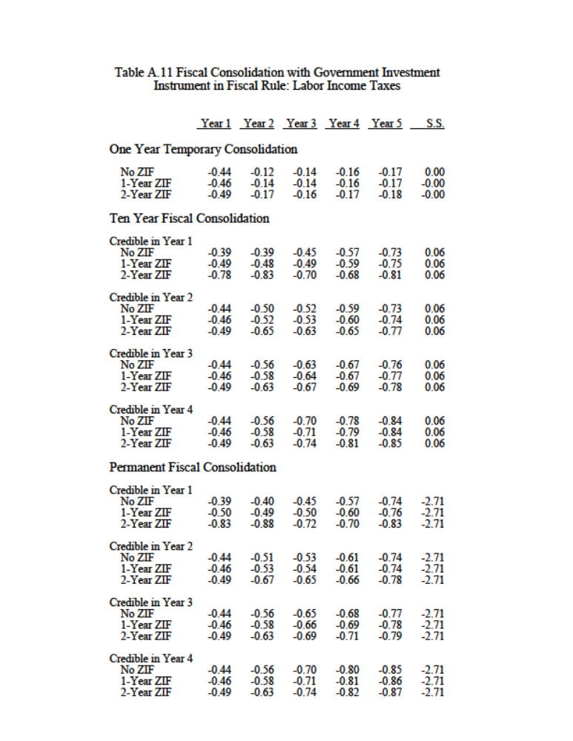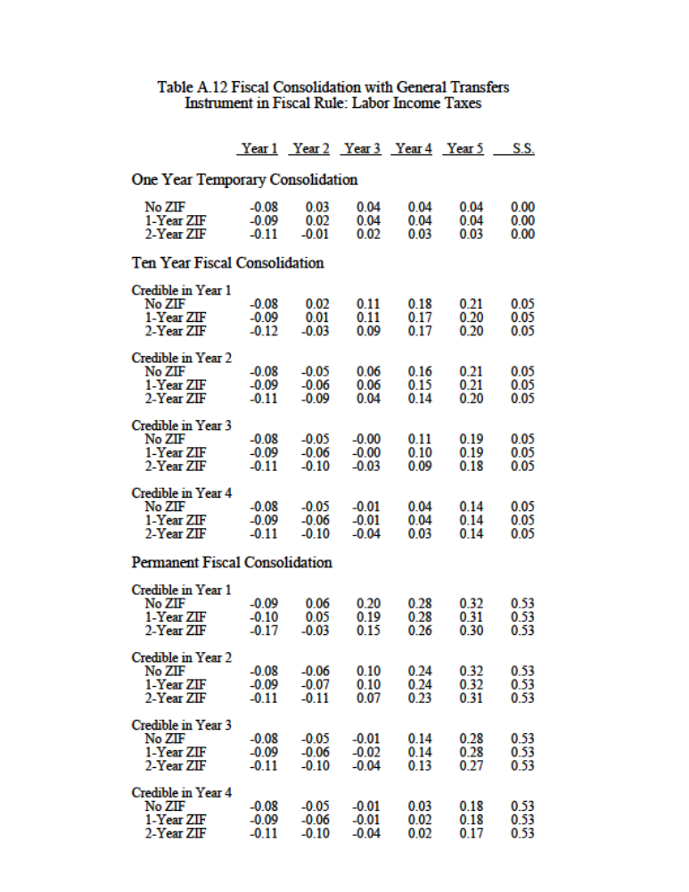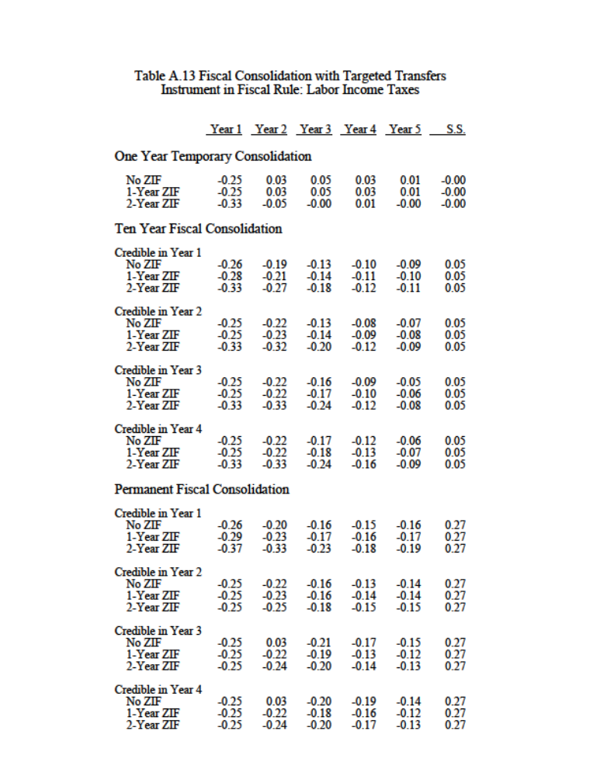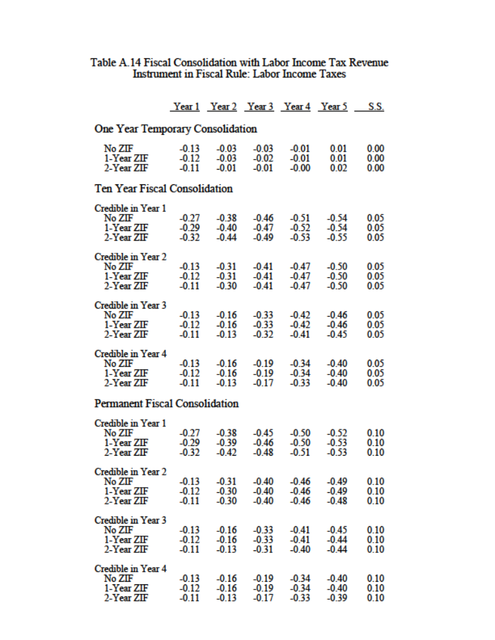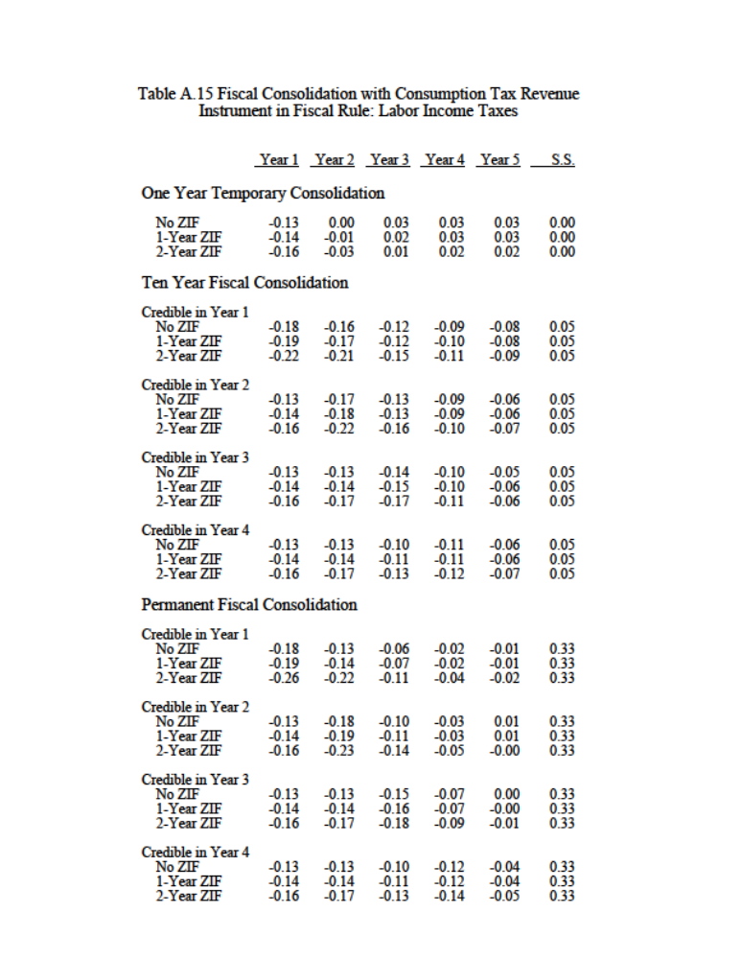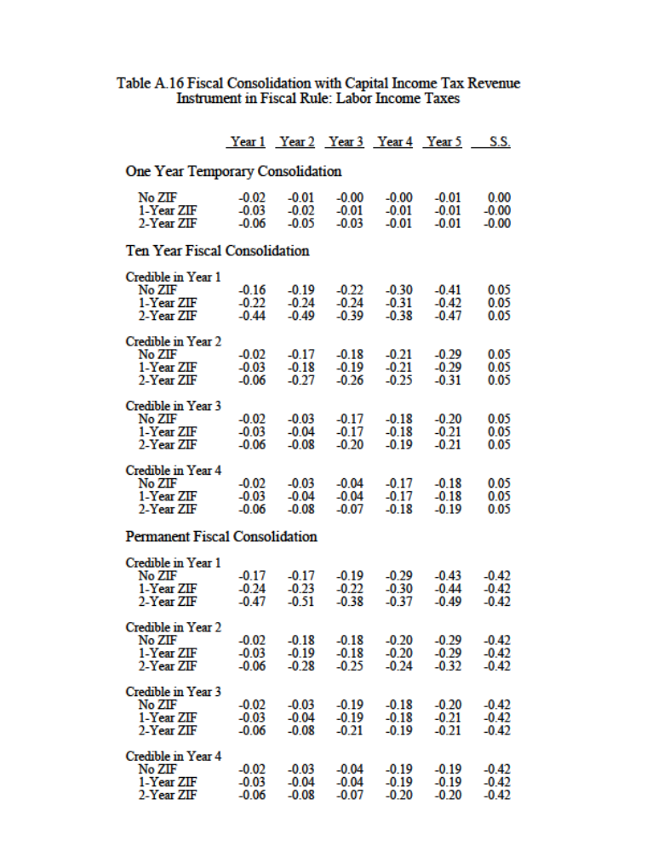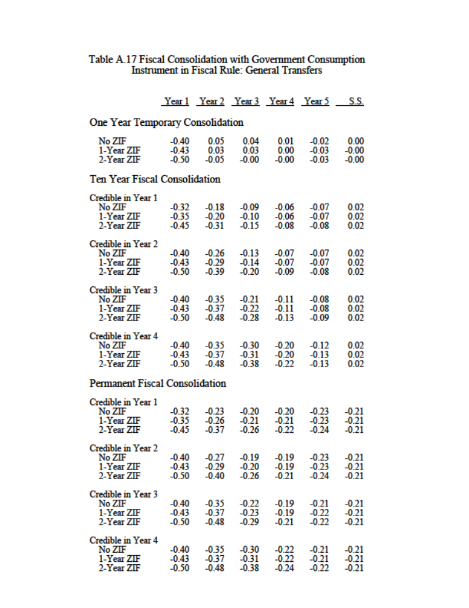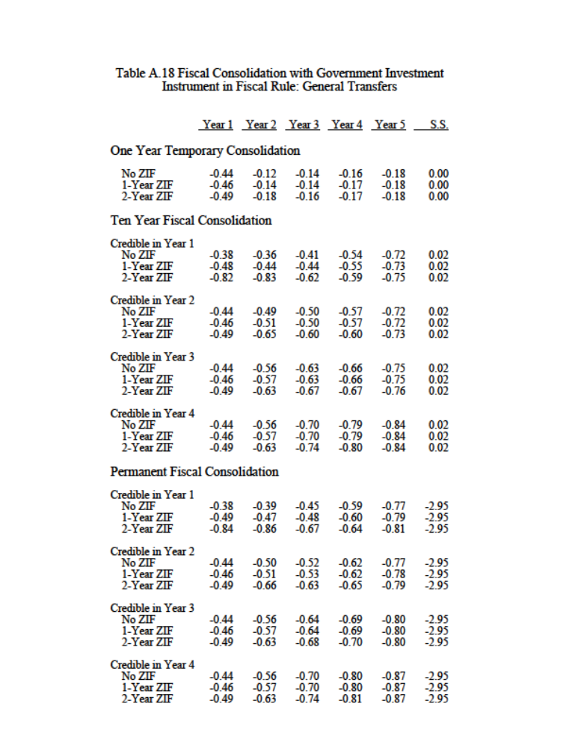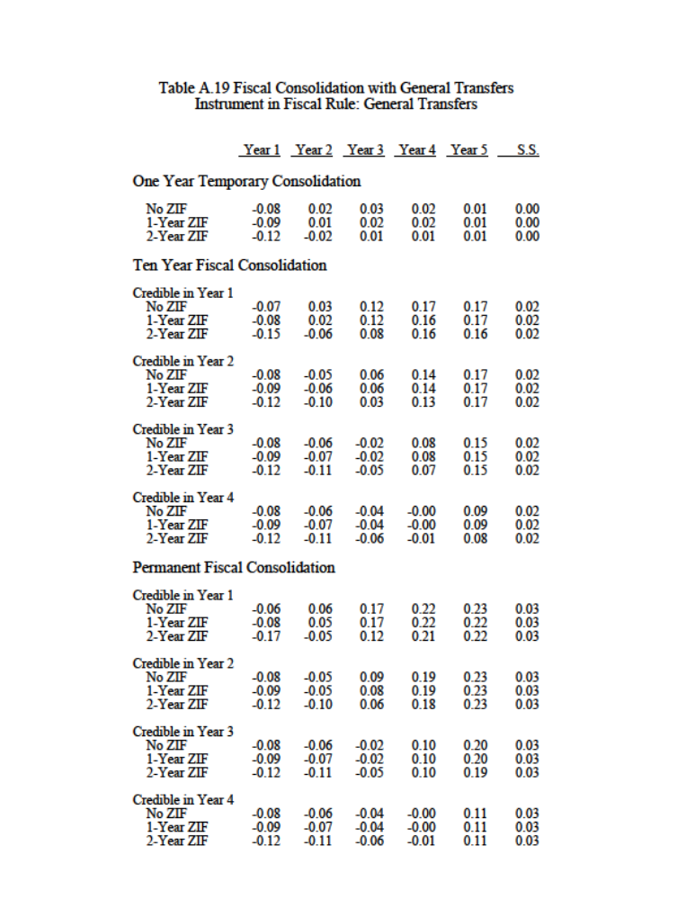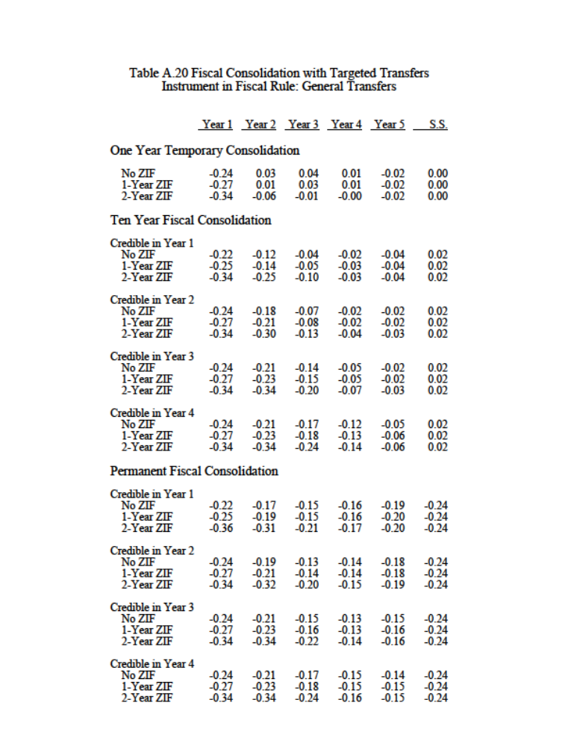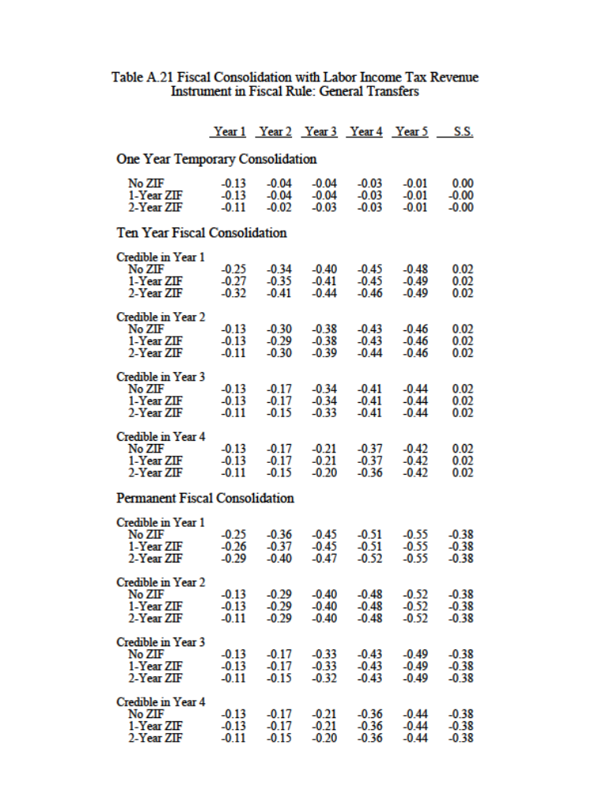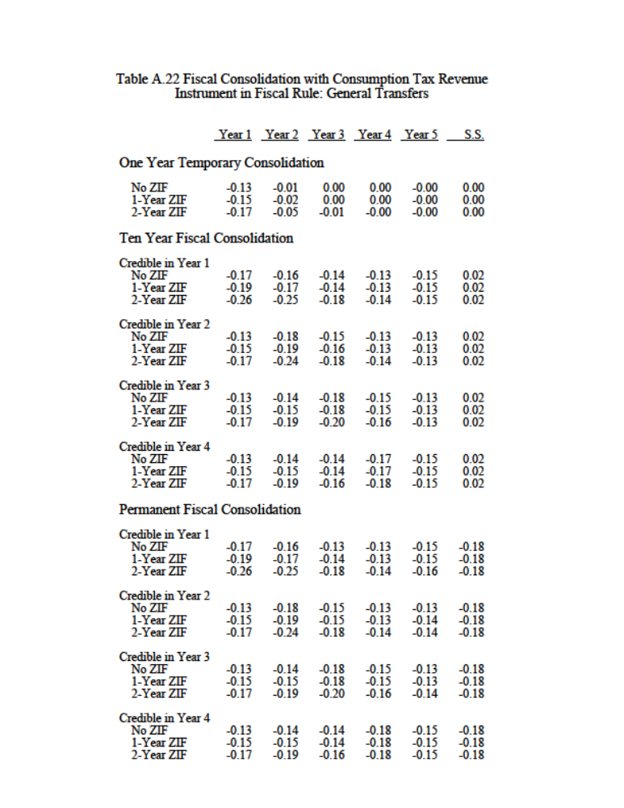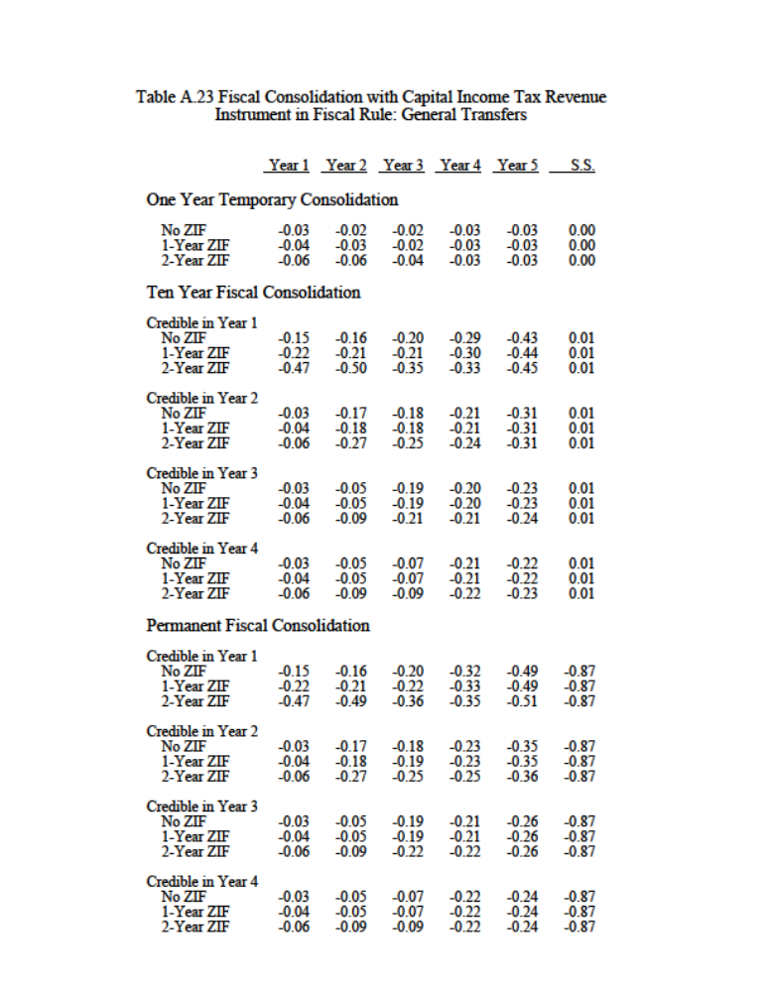
Appendix III 2011 Consolidation Package

The 2011 budget introduced a broad array of expenditure cuts and revenue-increasing measures adding up to 1.95 percent of GDP (not counting interest savings). The table below lists the key measures and how they map into GIMF instruments introduced in Section IV.

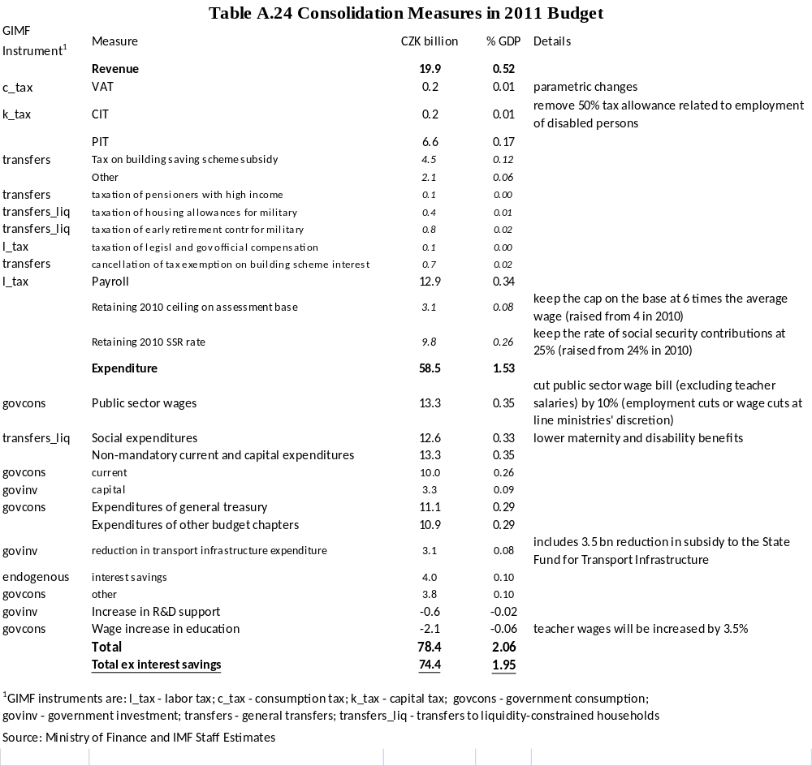

While the mapping is self-explanatory for most measures, several choices may be worth highlighting. The 50 percent tax on the government’s contribution to a saving scheme is effectively a reduction in the government’s transfer, hence it is coded as such. Similarly, taxation of pensions or allowances was considered a negative transfer. The decision of whether cuts in transfers were allocated to general or targeted ones was based on the perceived income level of the affected group. The official split of the 13.3 billion reduction in non-mandatory current and capital expenditures is not available. It was assumed that one quarter of that amount would come out of capital budgets. Measures affecting public sector wages were mapped into changes in government consumption. Expenditures of general treasury include transfers to subnational levels of government. It is assumed that local governments will cut their consumption commensurately.

The government plans to introduce a new lottery tax in 2012, with 5.5 billion korunas (0.14 percent of GDP) in estimated revenue. Little detail is available regarding that tax at this point, but most likely it will be structured similarly to the regular corporate income tax..

The summary results of our mapping of the 2011 consolidation package into GIMF instruments are shown in the table below, which is also reproduced in the main text.

