ONLINE APPENDIX

1)
This Appendix carries out the analysis of the money market interest rate differentials between the non-eurozone countries and the eurozone throughout the entire analysed period, without taking into consideration the exchange rate movements. For the sake of clarity and brevity only the average interest rate differentials over three sub-periods (1995:Q1 – 2004:Q4; 2005:Q1 – 2008:Q3; 2008:Q4 – 2011:Q4) are reported.

However, when one analyses the whole period, some obvious trends in interest rate differentials can be noticed. First, it is clear that there is a general downward trend in interest rate differentials over time (1995 – 2011). There were short periods of deviation from this trend during certain sub-periods. These changes are the result of external influences, such as the spillover of financial crises from other countries, but also the result of some domestic factors, such as the decision to change the exchange rate regime, which have had an impact on the movement of the risk premium in some countries. For example, in 1998 there was a short-term increase in the value of interest rate differentials reflecting the Russian financial crisis and the consequent increase in risk premiums in all CEE countries.

Throughout most of the 2000s there was a trend of declining interest rate differentials across the board. However, renewed growth in interest rate differentials took place in the last quarter of 2008 due to the spread of the global financial crisis and the sharp increase in the risk premium in all analysed countries. The peak was reached in mid-2009, after which they started to decline to pre-crisis levels due to the normalisation of the situation in the financial markets.

The table below summarizes the story. It is evident that the values of interest rate differentials were lower in between 2005:Q1 and 2008:Q3 than in the preceding period. But the outbreak of the global financial crisis in late 2008 turned the trend as average values of interest rate differentials in most countries became significantly higher than in the pre-crisis period.

Table A. Money market interest rate differentials between non-eurozone countries and the eurozone, average values over three sub-periods
 | 1995:Q1-2004:Q4 | 2005:Q1-2008:Q3 | 2008:Q4-2011:Q4
Bulgaria | 21.85 | 0.10 | 0.34
Czech Rep. | 4.01 | -0.41 | 0.83
Croatia | 5.09 | 0.49 | 3.00
Latvia | 2.63 | 0.34 | 1.14
Lithuania | 4.20 | -0.10 | 0.06
Hungary | 12.10 | 4.29 | 6.70
Poland | 12.02 | 1.60 | 2.79
Romania | 47.04 | 5.44 | 6.81
Source: IMF – IFS, author's calculations

2)
In several scatter plots Croatia appears as an outlier. For robustness check purposes, correlations excluding Croatia have been calculated to verify whether the results still hold. In case of Figure 7, Figure 8 and Figure 10 the coefficients of determination significantly drop and the correlations between the variables do not seem as strong. The plots are reported below.

Figure 7. Correlation of the financial component with total capital inflows vs. the intensity of the sudden stop in total capital inflows (in percent of GDP)
(a) Pre-crisis period (b) Crisis period
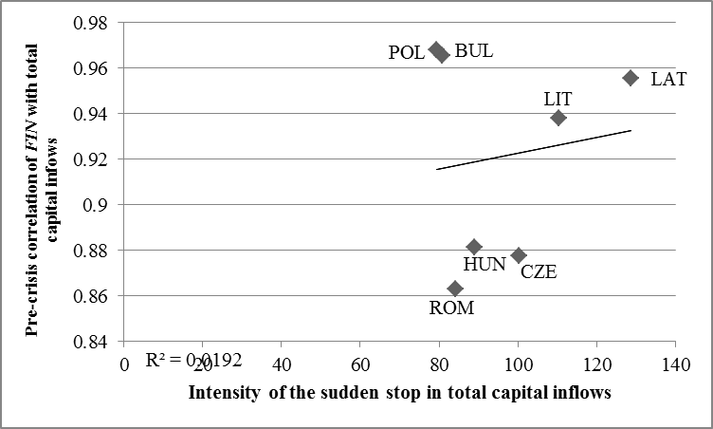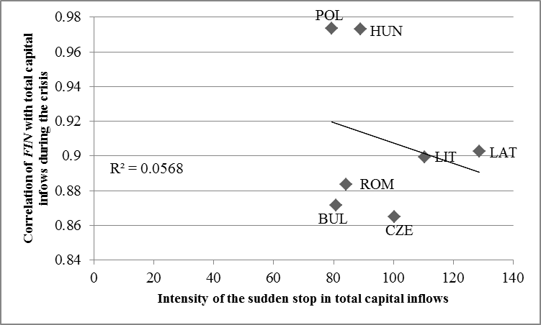

Figure 8. Correlation of the financial component with total capital inflows vs. the volatility of total capital inflows (standard deviation)
(a) Pre-crisis period (b) Crisis period
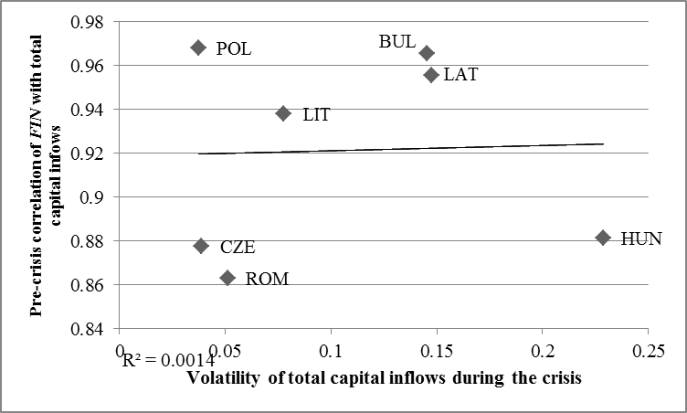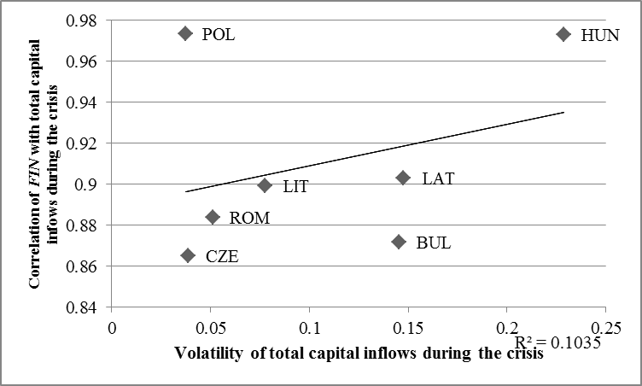

Figure 10. Intensity of the sudden stop in the financial component of capital flows (in percent of GDP) vs. the intensity of the sudden stop in total capital inflows (in percent of GDP)
